**Southern University Bangladesh**

**Department of Computer Science and Engineering**

**Faculty of Science and Engineering**



**Object Oriented Programming Lab**

**Lab Report: 03**

**Course code : CSE 0613-108**

**Submitted by:**

**Name : Sharmistha Chowdhury**

**ID: 666-61-60**

**Submitted to :**

**Mohammed Arif Hasan Chowdhury, Assistant Professor**

**Dept. of Computer Science and Engineering**

**Date : 07/02/2024**

|  |  |  |
| --- | --- | --- |
|  | Index |  |
| Sl | Name of Program | Remarks |
| 1 | **Class Practice**: Write a Java program that calculates the area of a triangle |  |
| 2 | **Problem 01:** Create a class named “Student”with String variable “name”; and integer variable “roll_no”Assign the value of roll_no as “2”and that of name as “John” by creating an object of the class Student. |  |
| 3 | **Problem 02:**Write a program to print the area of a rectangle by creating a class named ‘Area’ having two methods. The first method, named as ‘setDim’, takes the length and breadth of the rectangle as parameters. The second method, named as ‘getArea’, returns the area of the rectangle. The length and breadth of the rectangle are entered through the keyboard. |  |
| 4 | **Problem 03:**Write a program to print the area and perimeter of a triangle having sides of 3, 4, and 5 units. Create a class named ‘Triangle’ without any parameter in its constructor**.** |  |
| 5 | **Problem 04:** Write a program to print the area and perimeter of a triangle having sides of 3, 4, and 5 units. Create a class named ‘Triangle1’ with a constructor that takes the three sides as its parameters. |  |
| 6 | **Problem 05:** Write a program to print the area of two rectangles having sides (4,5) and (5,8) respectively. Create a class named ‘Rectangle’ with a method named ‘Area’ which returns the area. The length and breadth are passed as parameters to its constructor. |  |
| 7 |  |  |
| 8 |  |  |
| 9 |  |  |
| 10 |  |  |
| 11 |  |  |
| 12 |  |  |
| 13 |  |  |
| 14 |  |  |
| 15 |  |  |

**Class Practice: Write a Java program that calculates the area of a triangle.**

**Objective:**

The objective of the program is to calculate the area of a triangle using user-provided base and height. It demonstrates basic Java concepts like user input, method creation, and mathematical calculations.

**Algorithm:**

* Start the program.
* Define a method named calTriA that takes two parameters: base and height. This method calculates the area of a triangle using the formula 0.5 * base * height and returns the result.
* In the main method, create a Scanner object to read user input.
* Print a message asking the user to enter the base of the triangle.
* Use the Scanner object to read the user’s input for the base and store it in a variable named base.
* Print a message asking the user to enter the height of the triangle.
* Use the Scanner object to read the user’s input for the height and store it in a variable named height.
* Call the calTriA method with base and height as arguments and store the returned value in a variable.
* Print the calculated area of the triangle.
* End the program.

**Code:**

import java.util.Scanner;

public class ClassPractice {

public static float calTriA(float base, float height) {

return 0.5f * base * height;

}

public static void main(String[] args) {

Scanner scanner = new Scanner(System.in);

System.out.println("Enter the base of the triangle:");

float base = scanner.nextFloat();

System.out.println("Enter the height of the triangle:");

float height = scanner.nextFloat();

System.out.println("Area of triangle: " + calTriA(base, height));

}

}

**Input/ Expected Output:**

Enter the base of the triangle: 5

Enter the height of the triangle: 7

Area of triangle: 17.5

**Screenshot of code edition window:**

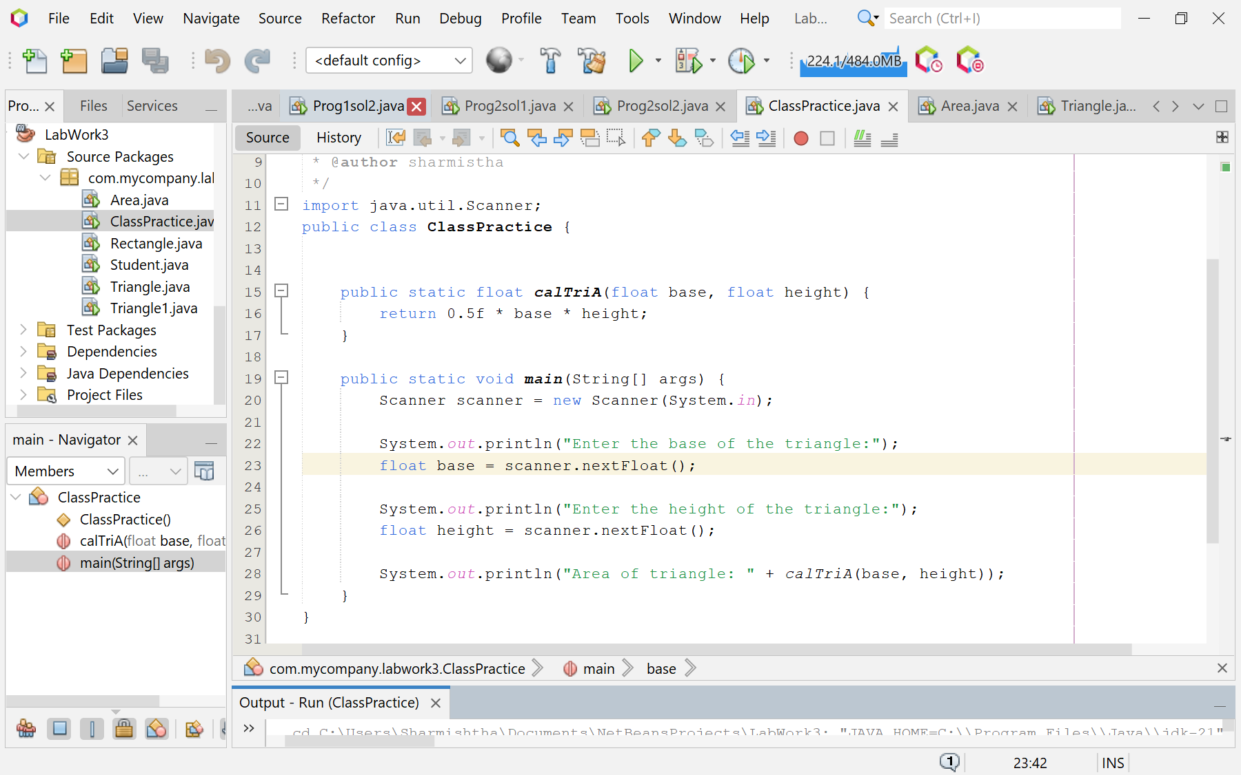

**Screenshot of Output screen/Run screen window**:

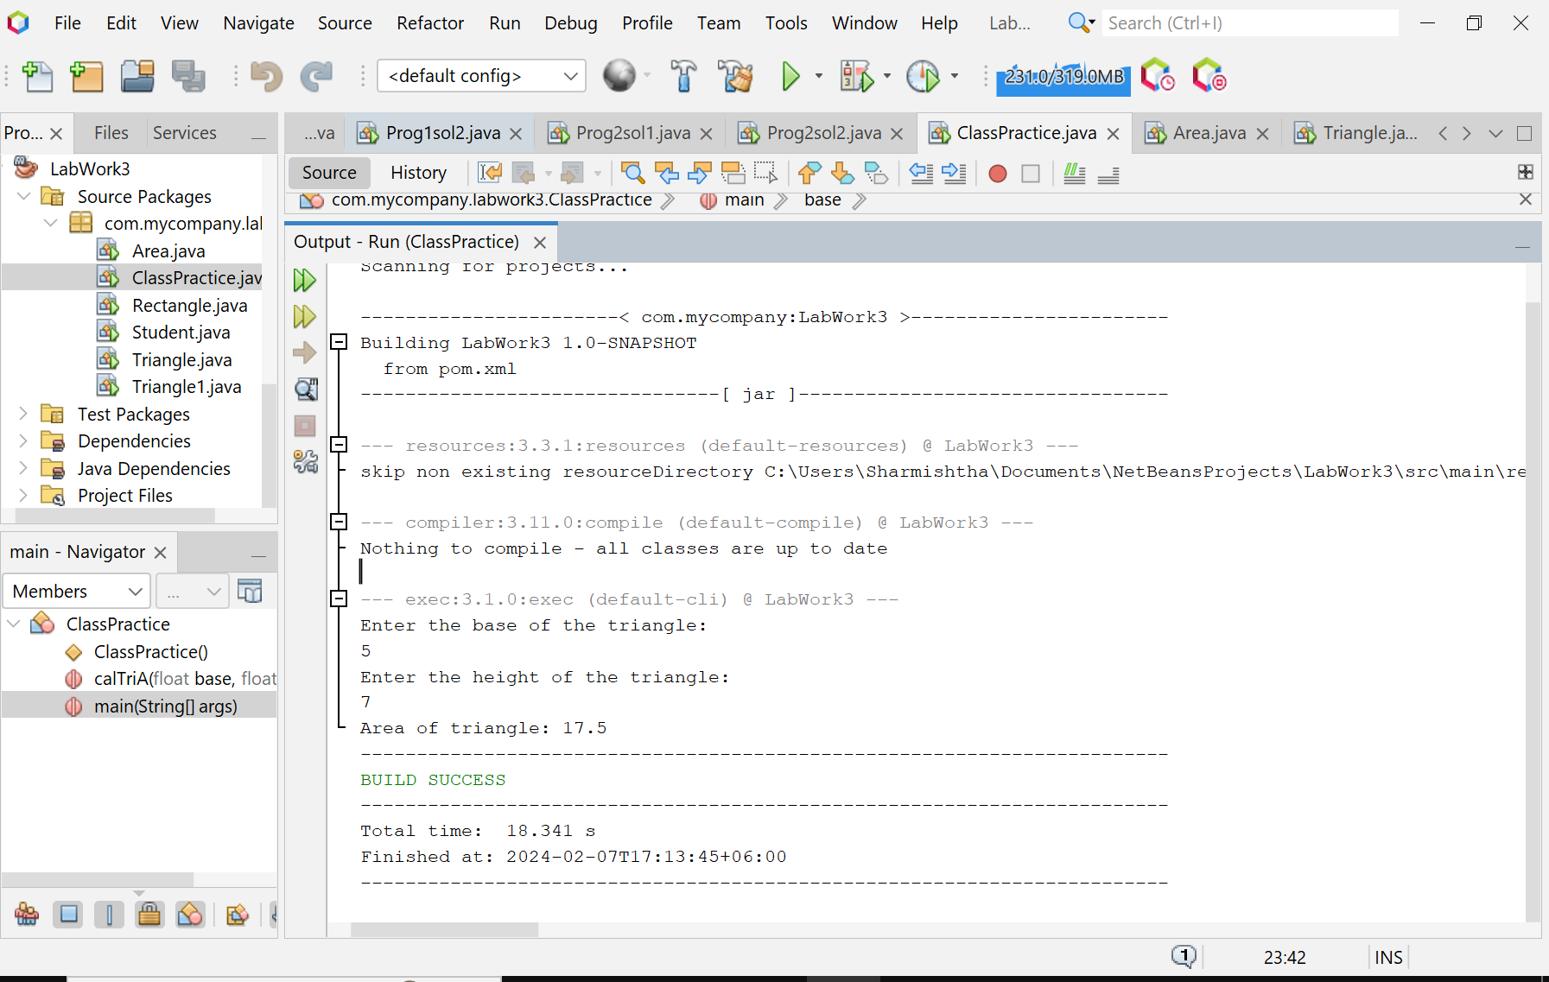

**Explanation:**

* The program begins by defining a method named calTriA that takes two parameters: base and height. This method calculates the area of a triangle using the formula: 0.5 * base * height and returns the result.
* In the main method, an instance of java.util.Scanner is created to read the input from the standard input (keyboard).
* The program then prompts the user to input the base and height of the triangle. These values are stored in the base and height variables, respectively.
* Next, the program calls the calTriA method with base and height as arguments. The result of this method call, which is the area of the triangle, is then printed to the standard output.

**Discussion**

This program effectively demonstrates the use of the Scanner class for user input and the creation of a method to perform a specific calculation in Java. However, it does not handle exceptions, such as when a user inputs a non-numeric value for the base or height. To make the program more robust, exception handling could be added. Additionally, the program currently performs operations with floating-point numbers, but it could be extended to handle other geometric calculations or shapes. Overall, this program serves as a good starting point for anyone learning to interact with users and perform basic operations in Java.

**Program 01: Create a class named “Student”with String variable “name”; and integer variable “roll_no”Assign the value of roll_no as “2”and that of name as “John” by creating an object of the class Student.**

**Objective:**

The program’s objective is to demonstrate basic object-oriented programming in Java by defining a Student class, creating an object of this class, and manipulating its instance variables. It showcases how to instantiate an object, assign values to its properties, and print these values.

**Algorithm:**

* Start the program.
* Define a class named Student with two instance variables: name (a String) and roll_no (an integer).
* Define the main method which is the entry point of the program.
* Begin the main method.
* Create an instance of the Student class and assign it to a variable named s.
* Assign the string “John” to the name variable of the s object.
* Assign the integer 2 to the roll_no variable of the s object.
* Print a message to the standard output that includes the name and roll_no of the s object.
* End the main method.
* End the program.

**Code:**

public class Student {

String name;

int roll_no;

public static void main(String[] args) {

Student s = new Student();

s.name = "John";

s.roll_no = 2;

System.out.println("Name is " + s.name + " and roll number is " + s.roll_no);

}

}

**Input/ Expected Output:**

Name is John and roll number is 2

**Screenshot of code edition window:**

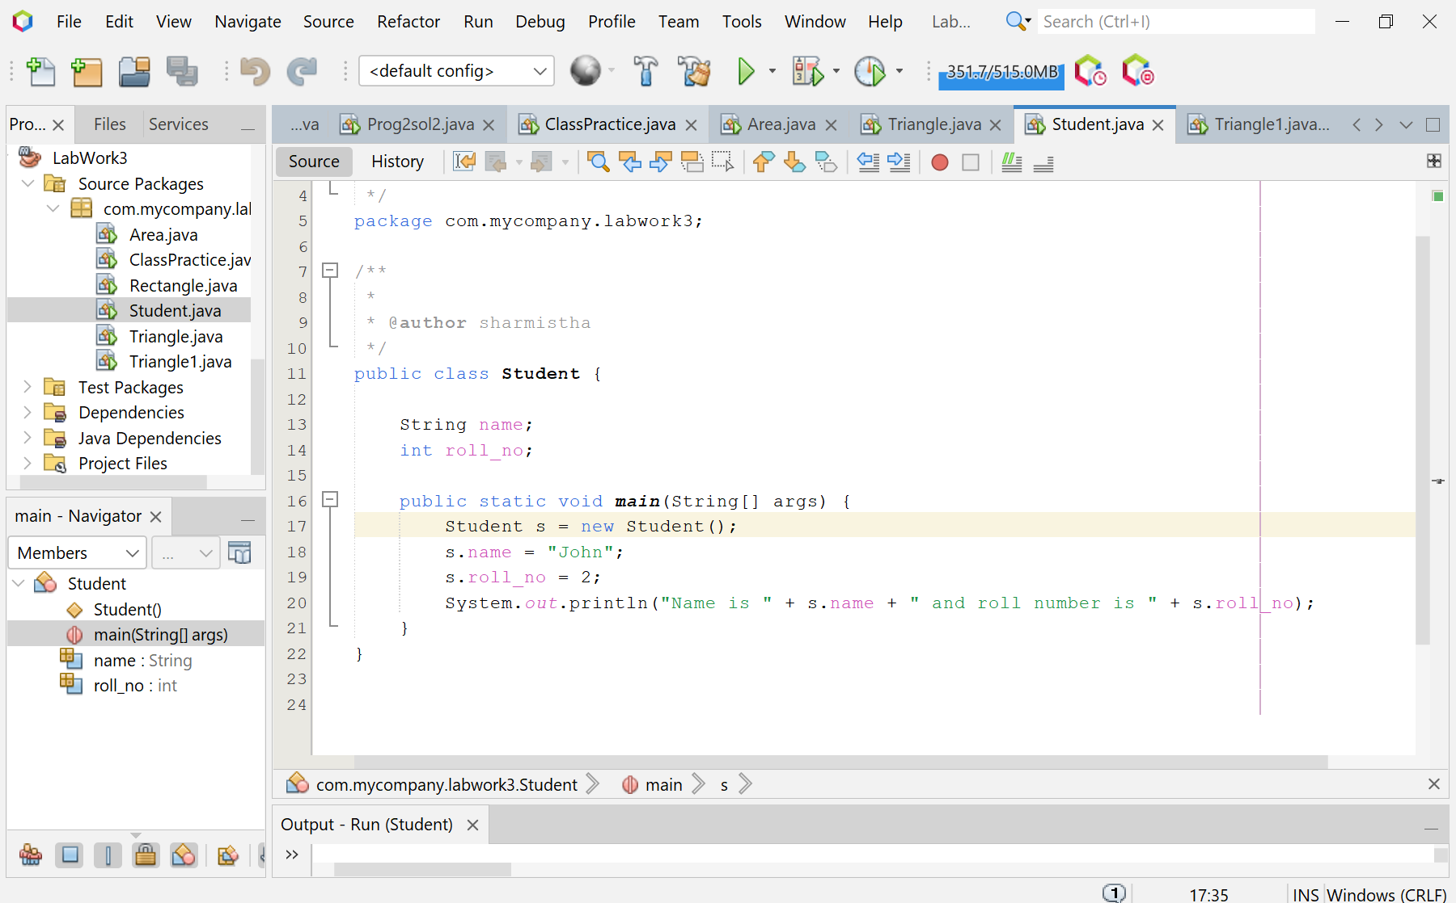

**Screenshot of Output screen/Run screen window**:

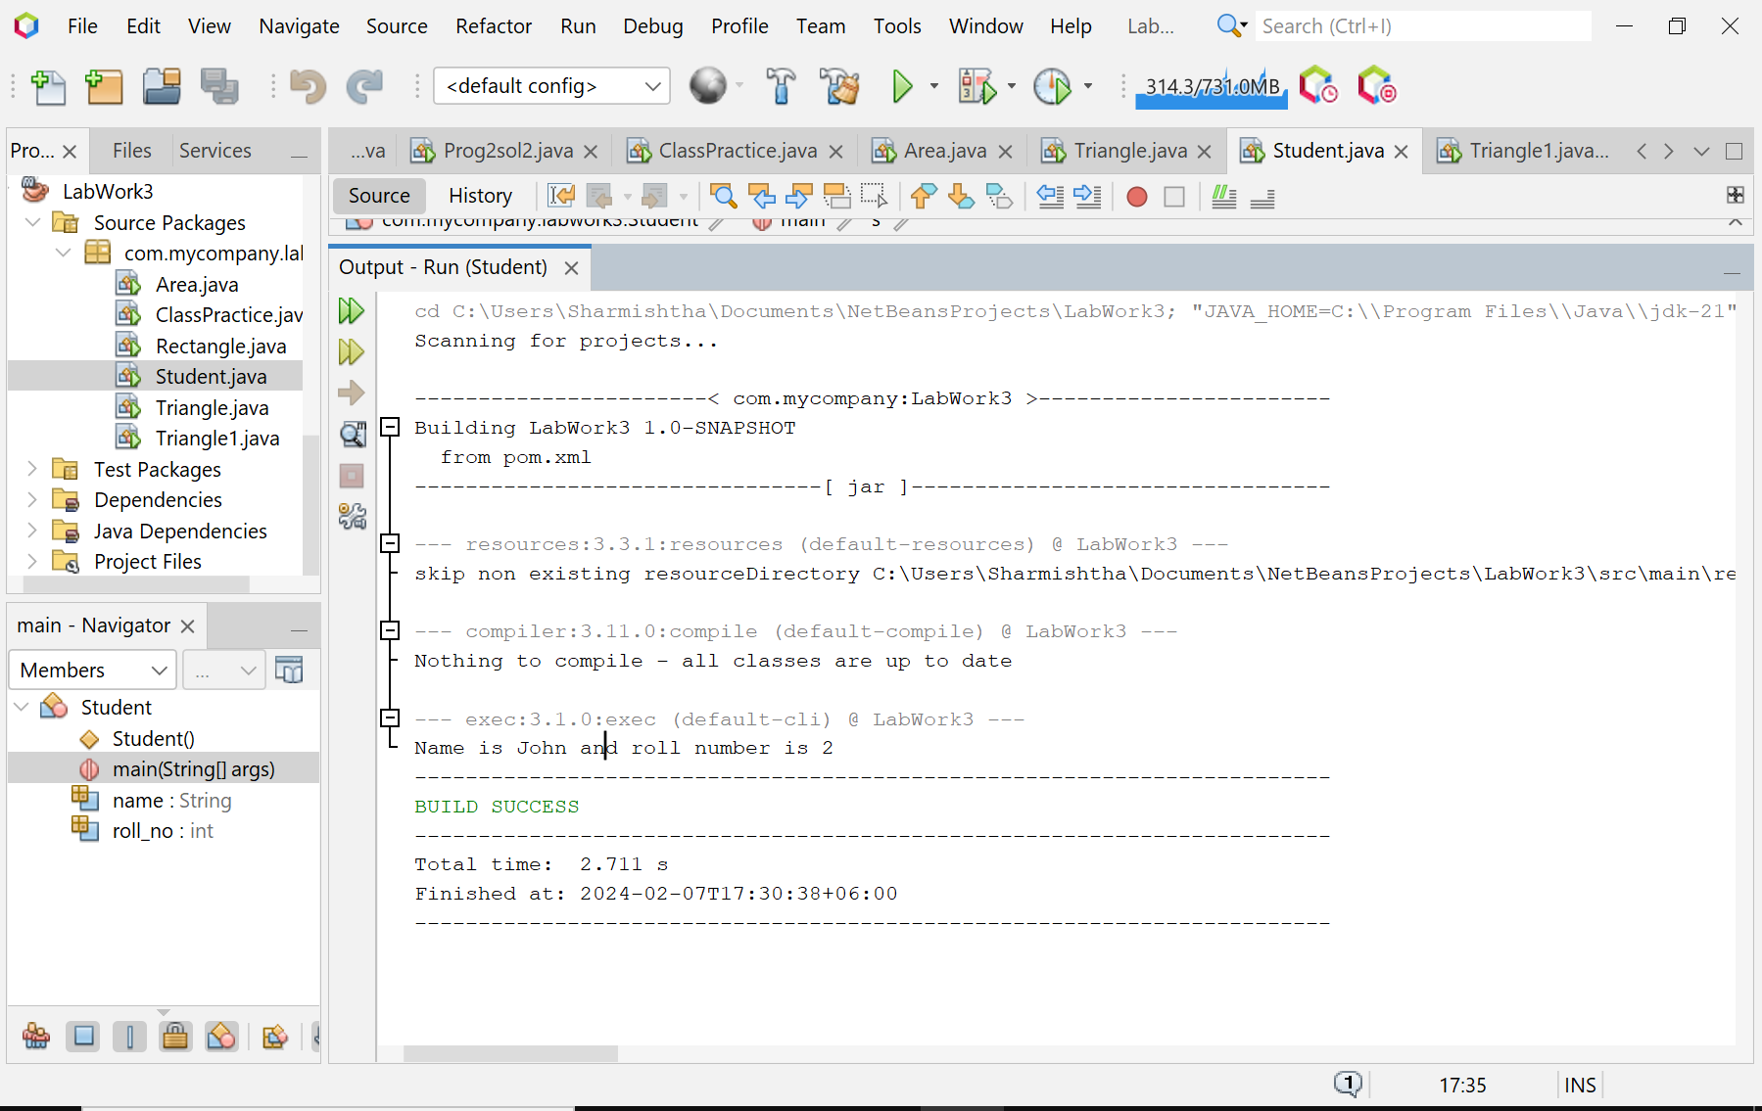

**Explanation :**

* The program begins by defining a class named Student with two instance variables: name (a String) and roll_no (an integer).
* In the main method, an instance of the Student class is created and assigned to a variable named s.
* The name variable of the s object is assigned the string “John” and the roll_no variable of the s object is assigned the integer 2.
* The program then prints a message to the standard output that includes the name and roll_no of the s object.

**Discussion:**

This program effectively demonstrates the use of classes, objects, and instance variables in Java. It shows how to define a class, create an object of that class, and manipulate the instance variables of that object. However, it does not use constructors or methods, which are common features in object-oriented programming. To make the program more robust and representative of object-oriented programming, constructors and methods could be added. Additionally, the program currently only creates one object, but it could be extended to handle multiple Student objects for more complex scenarios. Overall, this program serves as a good starting point for anyone learning to use classes and objects in Java.

**Problem 02:** **Write a program to print the area of a rectangle by creating a class named ‘Area’ having two methods. The first method, named as ‘setDim’, takes the length and breadth of the rectangle as parameters. The second method, named as ‘getArea’, returns the area of the rectangle. The length and breadth of the rectangle are entered through the keyboard.**

**Objective:**

The objective of the program is to create a class named ‘Area’ that calculates and prints the area of a rectangle. The class has two methods: ‘setDim’ to set the dimensions of the rectangle, and ‘getArea’ to calculate and return the area..

**Algorithm:**

* Start the program.
* Define a class named ‘Area’ with two methods: ‘setDim’ and ‘getArea’.
* The ‘setDim’ method takes two parameters: length and breadth, which represent the dimensions of the rectangle.
* The ‘getArea’ method calculates the area of the rectangle using the formula length * breadth and returns the result.
* In the main method, create an instance of the java.util.Scanner class to read the input from the standard input (keyboard).
* Prompt the user to input the length and breadth of the rectangle.
* Use the nextFloat() method of the Scanner object to read the user’s input for the length and breadth and pass these values to the ‘setDim’ method of an ‘Area’ object.
* Call the ‘getArea’ method and store the returned value in a variable.
* Print the calculated area of the rectangle to the standard output.
* End the program.

**Code:**

import java.util.Scanner;

public class Area {

double length;

double breadth;

public void setDim(double lengthInput, double breadthInput) {

length = lengthInput;

breadth = breadthInput;

}

public double getArea() {

return length * breadth;

}

public static void main(String[] args) {

Scanner scanner = new Scanner(System.in);

System.out.println("Enter the length of the rectangle:");

double length = scanner.nextDouble();

System.out.println("Enter the breadth of the rectangle:");

double breadth = scanner.nextDouble();

Area rectangle = new Area();

rectangle.setDim(length, breadth);

System.out.println("Area of rectangle: " + rectangle.getArea());

}

}

**Input/ Expected Output:**

Enter the length of the rectangle: 5

Enter the breadth of the rectangle: 6

Area of rectangle: 30.0

**Screenshot of code edition window:**

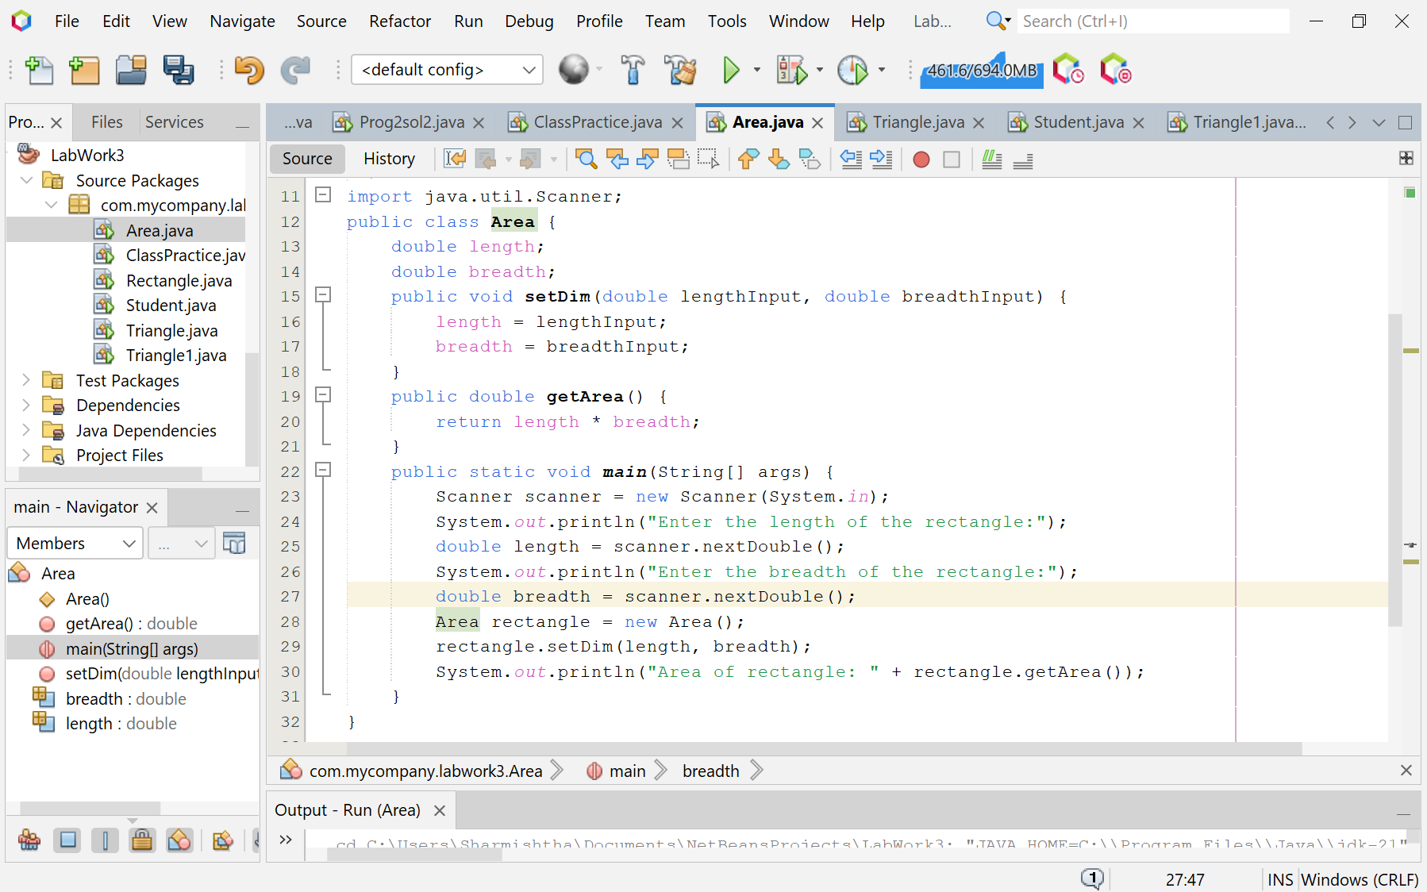

**Screenshot of Output screen/Run screen window**:

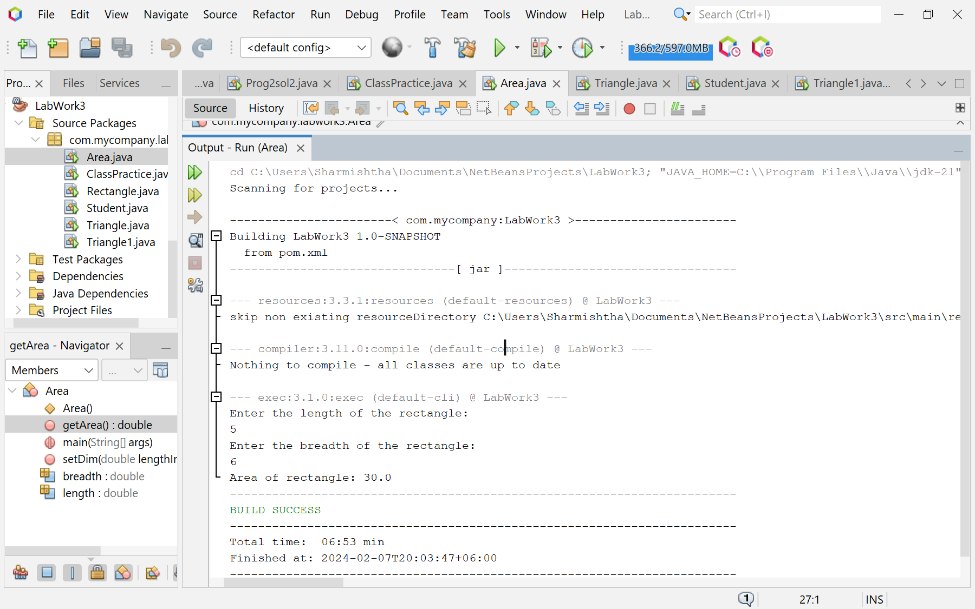

**Explanation :**

* The program begins by defining a class named ‘Area’ with two methods: ‘setDim’ and ‘getArea’.
* The ‘setDim’ method takes two parameters: length and breadth, which represent the dimensions of the rectangle.
* The ‘getArea’ method calculates the area of the rectangle using the formula length * breadth and returns the result.
* In the main method, an instance of the java.util.Scanner class is created to read the input from the standard input (keyboard).
* The program then prompts the user to input the length and breadth of the rectangle. These values are passed to the ‘setDim’ method of an ‘Area’ object.
* Finally, the ‘getArea’ method is called, and the calculated area is printed to the standard output.

**Discussion:**

This program is a simple example of how to use classes, methods, and user input in Java. It could be extended to handle different shapes and more complex geometric calculations. This program is a good starting point for beginners to understand basic Java programming concepts such as class creation, method definition, and object instantiation.

**Problem 03: Write a program to print the area and perimeter of a triangle having sides of 3, 4, and 5 units. Create a class named ‘Triangle’ without any parameter in its constructor.**

**Objective:**

The objective of the program is to calculate and display the area and perimeter of a triangle with given side lengths. The program defines a ‘Triangle’ class with methods for calculating the area and perimeter, and uses these methods to compute and print the results..

**Algorithm:**

* Start the program.
* Define a class named ‘Triangle’ with three instance variables: side1, side2, and side3.
* Define a method named ‘getArea’ that calculates the semi-perimeter of the triangle and then uses Heron’s formula to calculate and return the area.
* Define a method named ‘getPerimeter’ that calculates and returns the perimeter of the triangle.
* In the main method, create an instance of the Triangle class.
* Call the ‘getArea’ method of the Triangle object and print the returned value.
* Call the ‘getPerimeter’ method of the Triangle object and print the returned value.
* End the program.

**Code:**

public class Triangle {

double side1 = 3;

double side2 = 4;

double side3 = 5;

public double getArea() {

double s = (side1 + side2 + side3) / 2;

return Math.sqrt(s * (s - side1) * (s - side2) * (s - side3));

}

public double getPerimeter() {

return side1 + side2 + side3;

}

public static void main(String[] args) {

Triangle triangle = new Triangle();

System.out.println("Area of triangle: " + triangle.getArea());

System.out.println("Perimeter of triangle: " + triangle.getPerimeter());

}

}

**Input/ Expected Output:**

Area of triangle: 6.0

Perimeter of triangle: 12.0

**Screenshot of code edition window:**

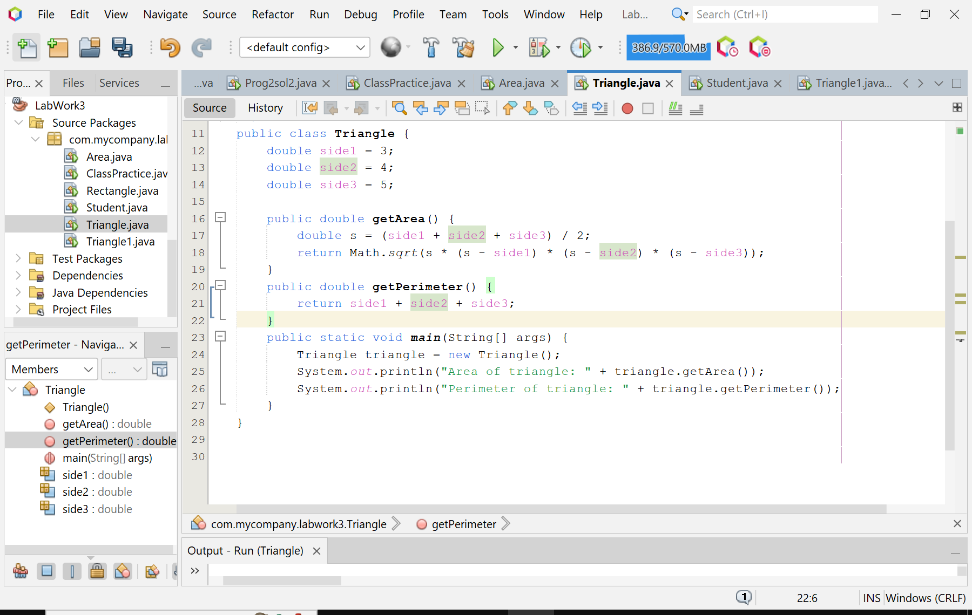**Screenshot of Output screen/Run screen window**:

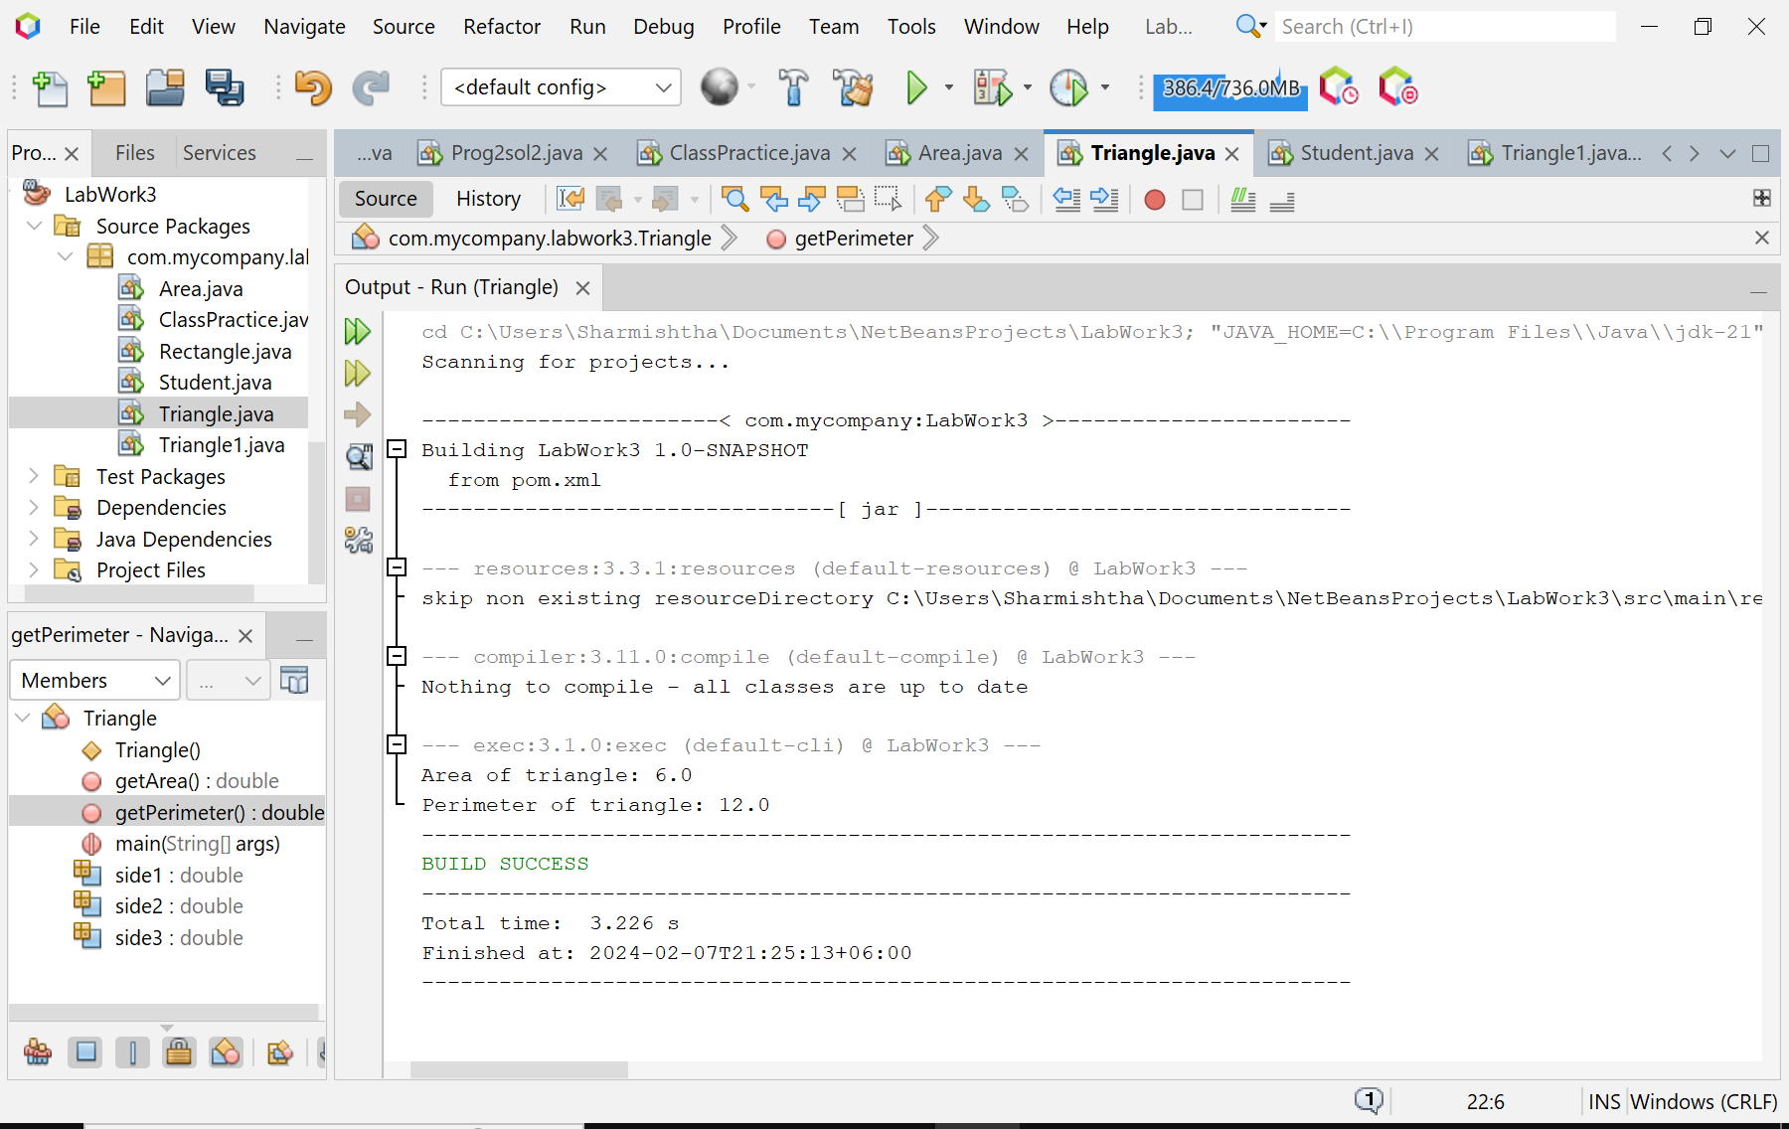

**Explanation :**

* + The program begins by defining a class named ‘Triangle’ with three instance variables: side1, side2, and side3, which represent the sides of the triangle.
  + The ‘getArea’ method calculates the semi-perimeter (s) of the triangle using the formula (side1 + side2 + side3) / 2 and then calculates the area using Heron’s formula: Math.sqrt(s * (s - side1) * (s - side2) * (s - side3)).
  + The ‘getPerimeter’ method calculates the perimeter of the triangle using the formula side1 + side2 + side3.
  + In the main method, an instance of the Triangle class is created and the ‘getArea’ and ‘getPerimeter’ methods are called to calculate and print the area and perimeter of the triangle.

**Discussion:**

This program is a simple example of how to use classes, instance variables, and methods in Java. It could be extended to handle different shapes and more complex geometric calculations. This program is a good starting point for beginners to understand basic Java programming concepts such as class creation, method definition, and object instantiation.

**Problem 04:** **Write a program to print the area and perimeter of a triangle having sides of 3, 4, and 5 units. Create a class named ‘Triangle1’ with a constructor that takes the three sides as its parameters**.

**Objective:**

The objective of the program is to create a class named ‘Triangle1’ that calculates and displays the area and perimeter of a triangle with given side lengths. The program defines a ‘Triangle1’ class with a constructor that takes the three sides as parameters, and methods for calculating the area and perimeter.

**Algorithm:**

* Start the program.
* Define a class named ‘Triangle1’ with three instance variables: side1, side2, and side3.
* Define a constructor for the ‘Triangle1’ class that takes three parameters: side1Input, side2Input, and side3Input. Use these parameters to initialize the instance variables side1, side2, and side3.
* Define a method named ‘getArea’ that calculates the semi-perimeter of the triangle and then uses Heron’s formula to calculate and return the area.
* Define a method named ‘getPerimeter’ that calculates and returns the perimeter of the triangle.
* In the main method, create an instance of the Triangle1 class with the sides of the triangle set to 3, 4, and 5.
* Call the ‘getArea’ method of the Triangle1 object and print the returned value.
* Call the ‘getPerimeter’ method of the Triangle1 object and print the returned value.
* End the program.

**Code:**

public class Triangle1 {

double side1;

double side2;

double side3;

public Triangle1(double side1Input, double side2Input, double side3Input) {

side1 = side1Input;

side2 = side2Input;

side3 = side3Input;

}

public double getArea() {

double s = (side1 + side2 + side3) / 2;

return Math.sqrt(s * (s - side1) * (s - side2) * (s - side3));

}

public double getPerimeter() {

return side1 + side2 + side3;

}

public static void main(String[] args) {

Triangle1 triangle = new Triangle1(3, 4, 5);

System.out.println("Area of triangle: " + triangle.getArea());

System.out.println("Perimeter of triangle: " + triangle.getPerimeter());

}

}

**Input/ Expected Output:**

Area of triangle: 6.0

Perimeter of triangle: 12.0

**Screenshot of code edition window:**

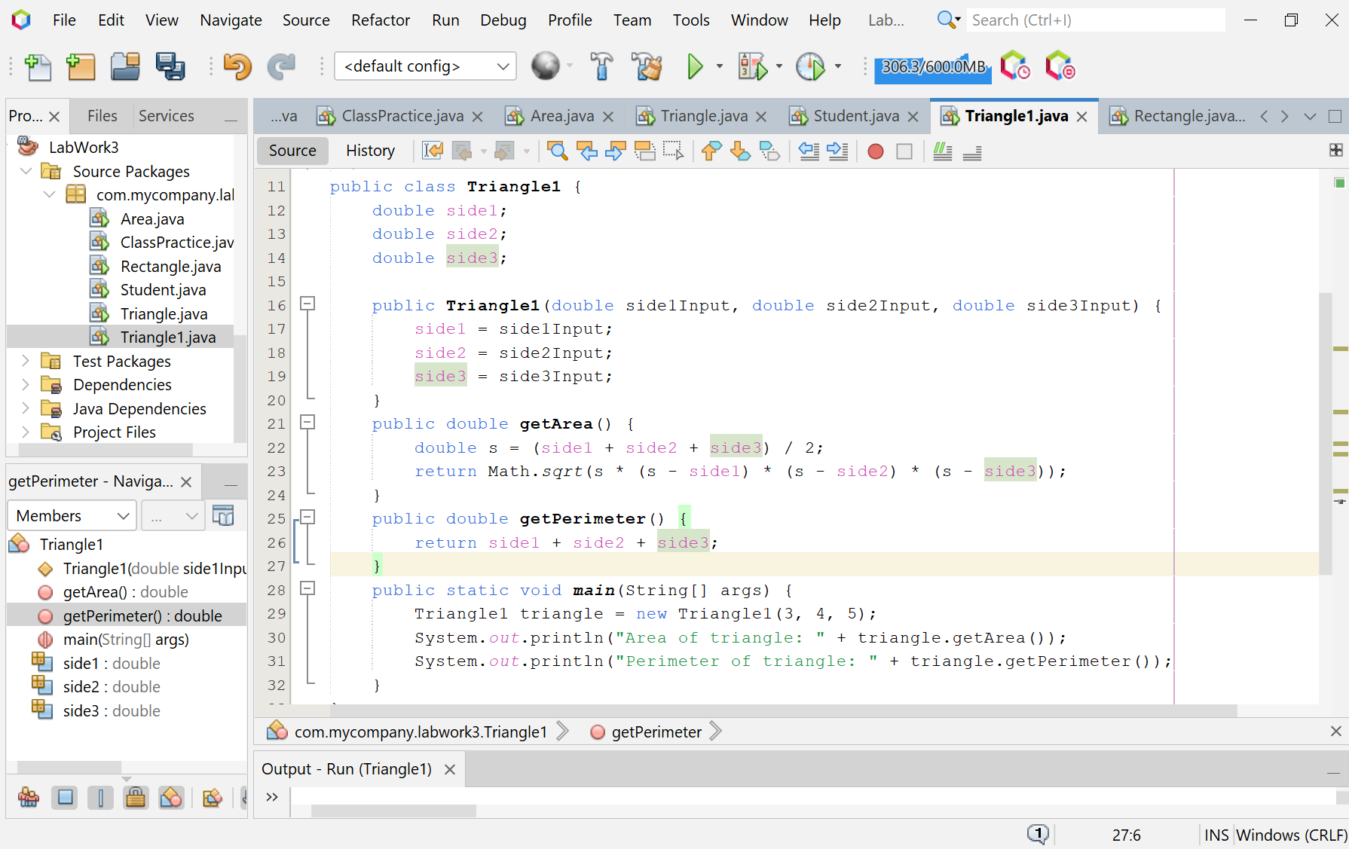

**Screenshot of Output screen/Run screen window**:

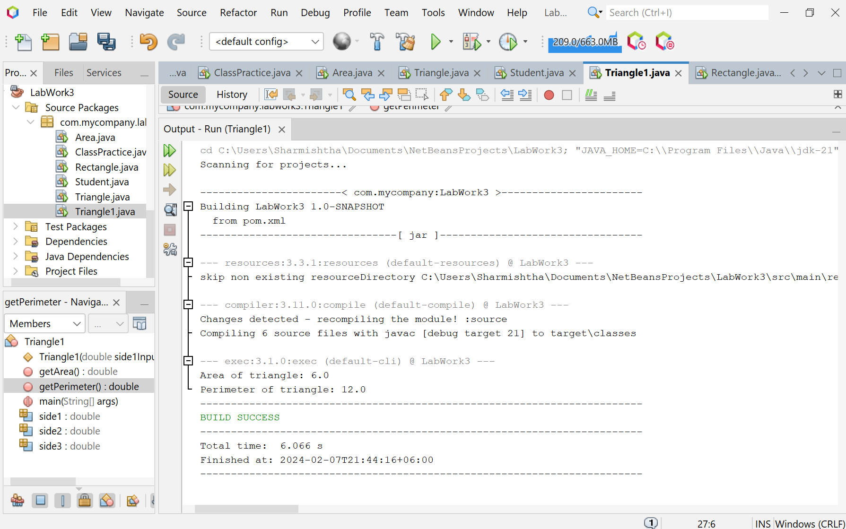

**Explanation :**

* The program begins by defining a class named ‘Triangle1’ with three instance variables: side1, side2, and side3, which represent the sides of the triangle.
* The ‘Triangle1’ class has a constructor that takes three parameters: side1Input, side2Input, and side3Input. These parameters are used to initialize the instance variables side1, side2, and side3.
* The ‘getArea’ method calculates the semi-perimeter (s) of the triangle using the formula (side1 + side2 + side3) / 2 and then calculates the area using Heron’s formula: Math.sqrt(s * (s - side1) * (s - side2) * (s - side3)).
* The ‘getPerimeter’ method calculates the perimeter of the triangle using the formula side1 + side2 + side3.
* In the main method, an instance of the Triangle1 class is created with the sides of the triangle set to 3, 4, and 5. The ‘getArea’ and ‘getPerimeter’ methods are then called to calculate and print the area and perimeter of the triangle.

**Discussion:**

This program is a simple example of how to use classes, constructors, instance variables, and methods in Java. It could be extended to handle different shapes and more complex geometric calculations. This program is a good starting point for beginners to understand basic Java programming concepts such as class creation, constructor definition, method definition, and object instantiation.

**Problem 05: Write a program to print the area of two rectangles having sides (4,5) and (5,8) respectively. Create a class named ‘Rectangle’ with a method named ‘Area’ which returns the area. The length and breadth are passed as parameters to its constructor**

**Objective:**

The objective of the program is to create a class named ‘Rectangle’ that calculates and displays the area of two rectangles with given dimensions. The program defines a ‘Rectangle’ class with a constructor that takes the length and breadth as parameters, and a method for calculating the area.

**Algorithm:**

* Start the program.
* Define a class named ‘Rectangle’ with two instance variables: length and breadth.
* Define a constructor for the ‘Rectangle’ class that takes two parameters: lengthInput and breadthInput. Use these parameters to initialize the instance variables length and breadth.
* Define a method named ‘Area’ that calculates and returns the area of the rectangle using the formula length * breadth.
* In the main method, create two instances of the Rectangle class with different dimensions.
* For each instance, call the ‘Area’ method and print the returned value.
* End the program.

**Code:**

public class Rectangle {

double length;

double breadth;

public Rectangle(double lengthInput, double breadthInput) {

length = lengthInput;

breadth = breadthInput;

}

public double Area() {

return length * breadth;

}

public double getPerimeter() {

return 2 * (length + breadth);

}

public static void main(String[] args) {

Rectangle rectangle1 = new Rectangle(4, 5);

System.out.println("Area of first rectangle: " + rectangle1.Area());

System.out.println("Perimeter of first rectangle: " + rectangle1.getPerimeter());

Rectangle rectangle2 = new Rectangle(5, 8);

System.out.println("Area of second rectangle: " + rectangle2.Area());

System.out.println("Perimeter of second rectangle: " + rectangle2.getPerimeter());

}

}

**Input/ Expected Output:**

Area of first rectangle: 20.0

Perimeter of first rectangle: 18.0

Area of second rectangle: 40.0

Perimeter of second rectangle: 26.0

**Screenshot of code edition window:**

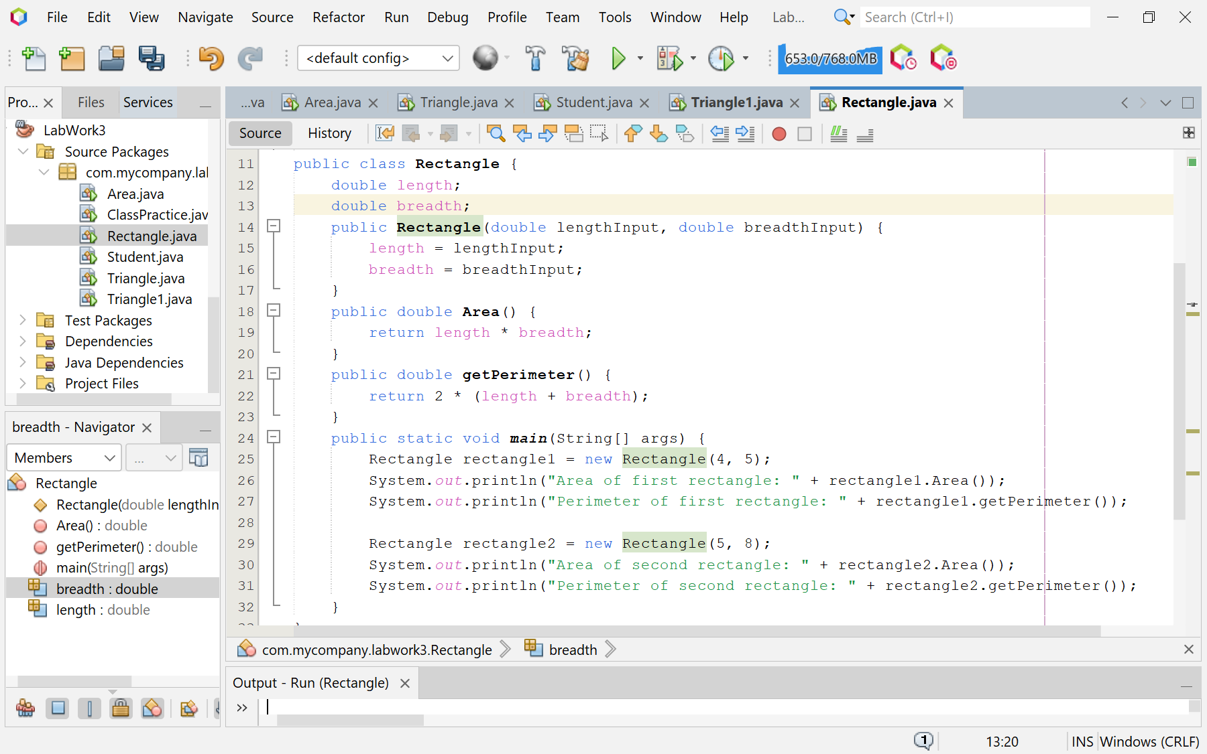

**Screenshot of Output screen/Run screen window**:

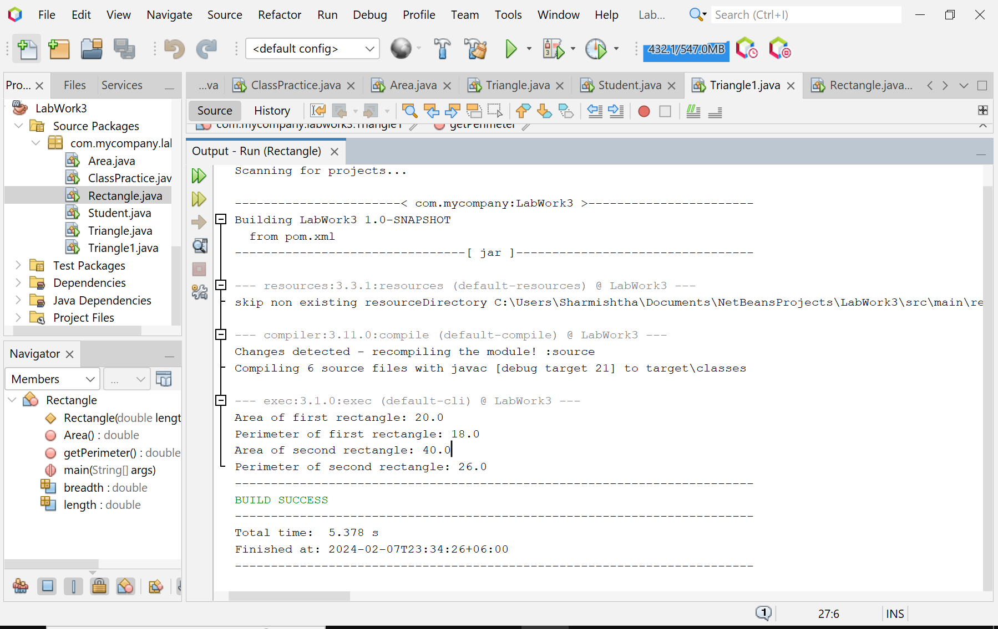

**Explanation :**

* The program begins by defining a class named ‘Rectangle’ with two instance variables: length and breadth, which represent the dimensions of a rectangle.
* The ‘Rectangle’ class has a constructor that takes two parameters: lengthInput and breadthInput. These parameters are used to initialize the instance variables length and breadth.
* The ‘Area’ method calculates the area of the rectangle using the formula length * breadth and returns the result.
* In the main method, two instances of the Rectangle class are created with different dimensions. The ‘Area’ method is then called on these instances, and the results are printed to the console.

**Discussion:**

This program is a simple example of how to use classes, constructors, instance variables, and methods in Java. It could be extended to handle different shapes and more complex geometric calculations. This program is a good starting point for beginners to understand basic Java programming concepts such as class creation, constructor definition, method definition, and object instantiation..